Oracle Database Administration
User password expired issue

Submitted to



By



CIS, Wipro Limited

Document Details

Project Name | Innogy SE
Account | CIS
IT Component/Application Title | KE_User password expire
Current Version | 1.5
List of Contributors | Abhishek Kansal , Kamlesh Sawant , Saurabh Nigam , Jiten Pansara, Sreya Puthukudy
Customer Contact Information

Version History
(All revisions made to this document must be listed in chronological order. All revisions must be approved. Review and Approval can be done by an internal source or by the customer)
Version | Date of Revision | Description | Author | Reviewed By | Approved By
1.0 | 29-08-2015 | Intial Draft | Kamlesh Sawant | Saurabh Nigam | Mahesh Keshatwar
1.1 | 04-09-2015 | Document Completed | Kamlesh Sawant | Saurabh Nigam | Mahesh Keshatwar
1.2 | 21-08-2016 | Updated document to standard format | Kamlesh Sawant | Saurabh Nigam | Mahesh Keshatwar
1.3 | 17-05-2017 | Wipro and Innogy Logo changed | Kamlesh Sawant | Jiten Patel | Mahesh Keshatwar
1.4 | 01-11-2017 | Updated document to Wipro Standard format with header and footer | Abhishek Kansal | Jiten Patel | Yogesh Desai
1.5 | 17-12-2018 | Updated the content | Sreya Puthukudy | Jiten Pansara | Santosh Badiger

Error Description:
ORA-28001: the password has expired
Impact:
User will not be able to login to database.
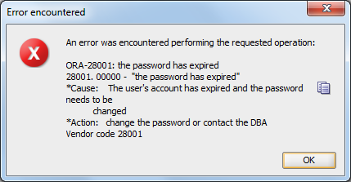
Workaround:
Need to reset password of the user with new password or old password.
1. Login to the server
2. ps -ef|grep pmon
3. Connect the database
4. Sqlplus "/ as sysdba"
5. select username, account_status from dba_users;
6. select name,password from sys.user$ where username='<user_name>';
7. alter user username identified by values '<password given by above command>';

